Fatima Jinnah Women University

Cloud Computing
Assignment 1
Submitted by :
Inshal Nasir
Submitted TO;
Sir Waqas Saleem
Section ;
A
Date:

16 Oct,2025

Task 1 run gitea in codespace and run initial repo:
- A Gitea server was set up and a new repository was created containing a README.md file listing student names and roll numbers.
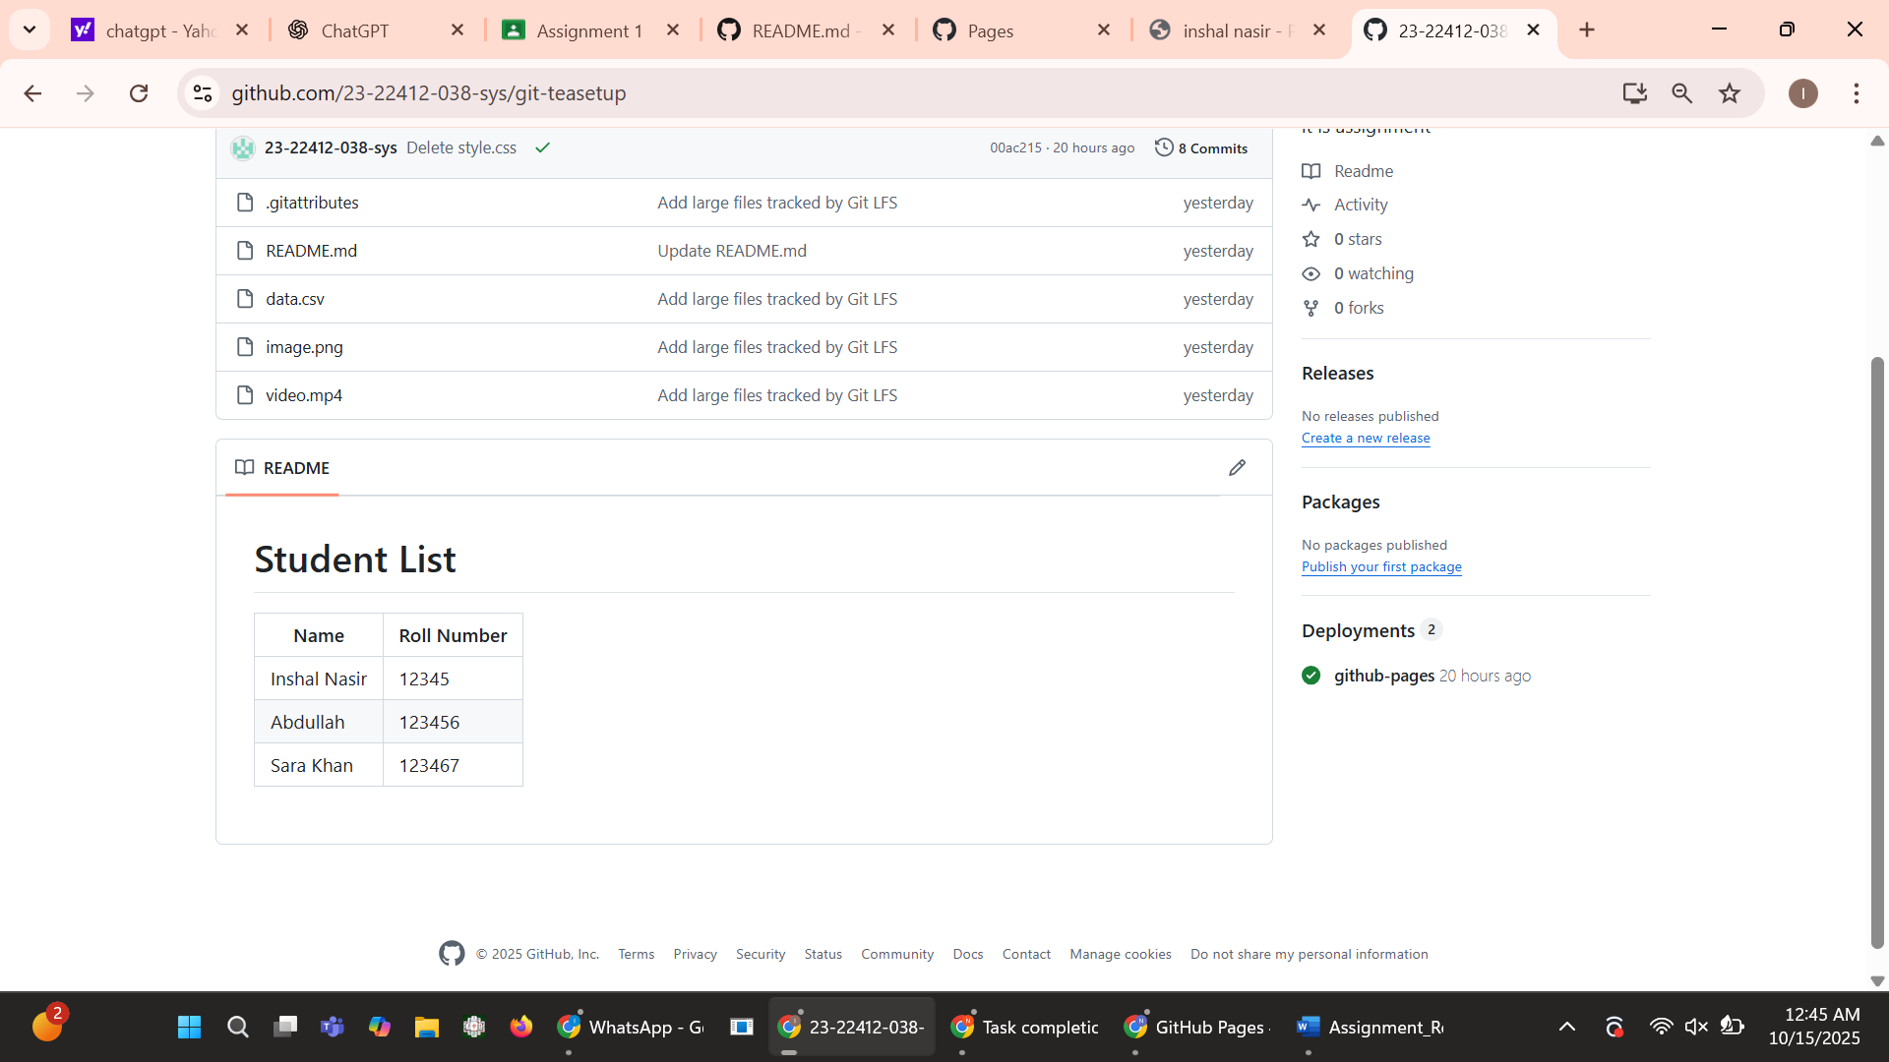
Task 2 Mirror readme.md from Gitea to GitHub:
- The repository from Gitea was mirrored to GitHub using a remote connection.
Commands used:
git remote add github <GitHub_repo_URL>
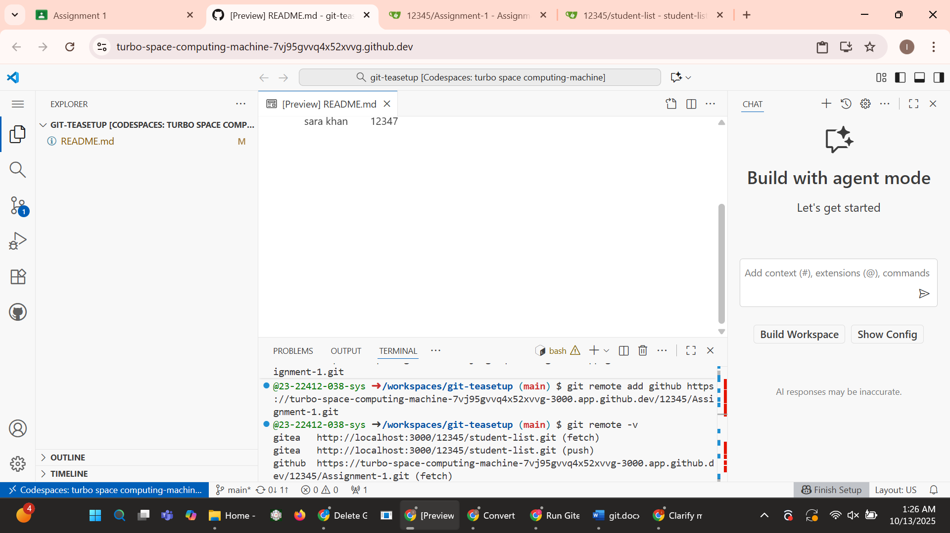
- git push git hub main
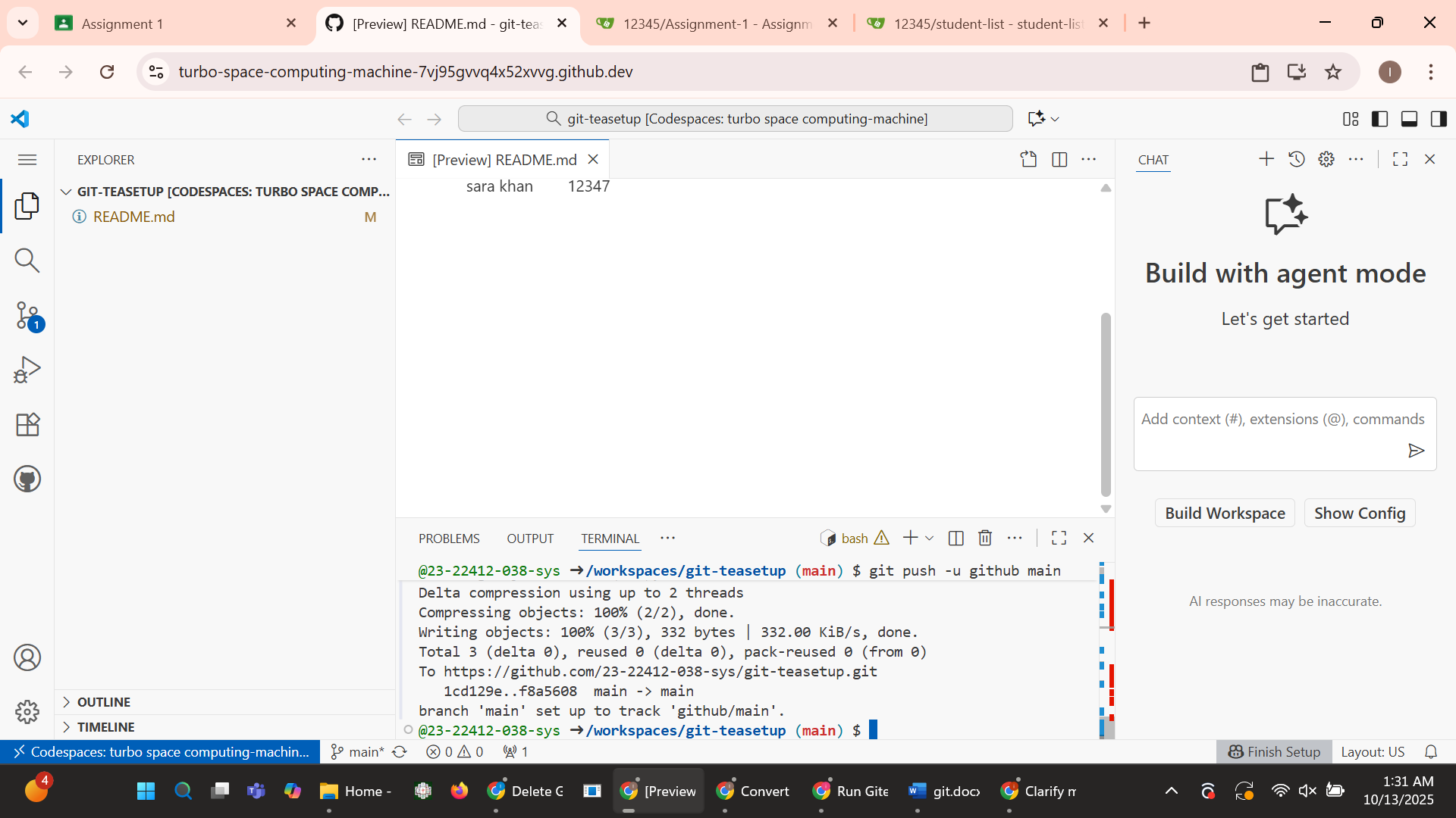
- Verify Remotes:
- Run git remote -v and ensure both remotes (gitea and github) are listed.
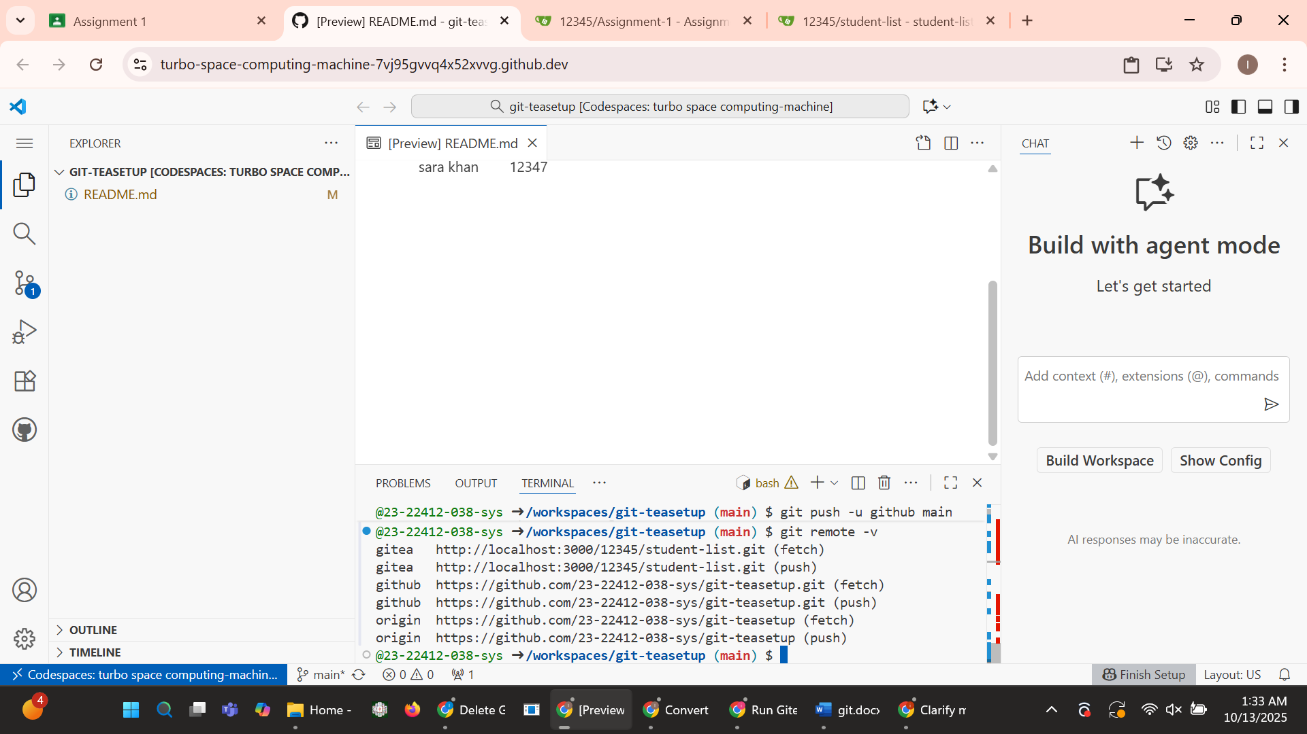
- GitHub Repository Link: https://turbo-space-computing-machine-7vj95gvvq4x52xvvg-3000.app.github.dev/
Task 3: Use Git LFS for Large Files:
- Add large files
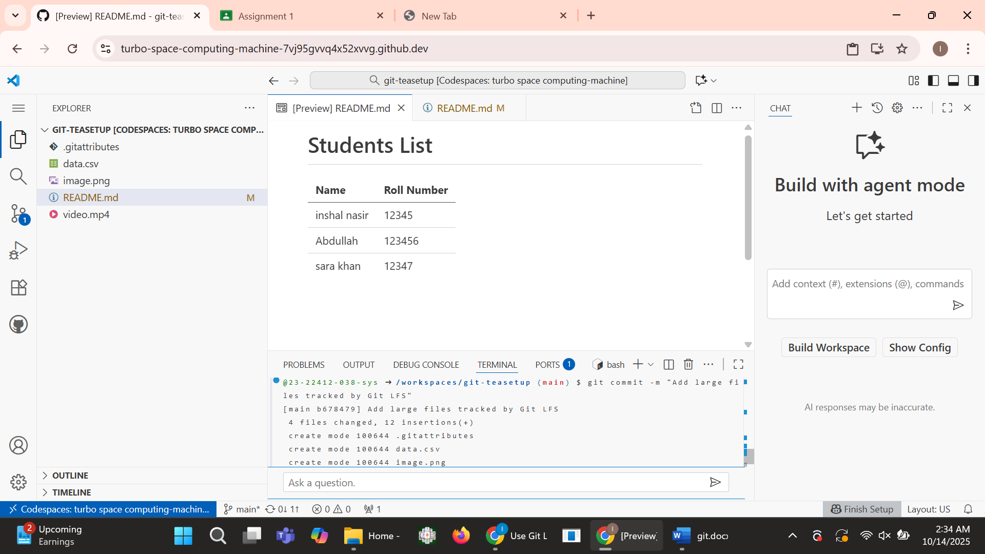
- Tracking large files
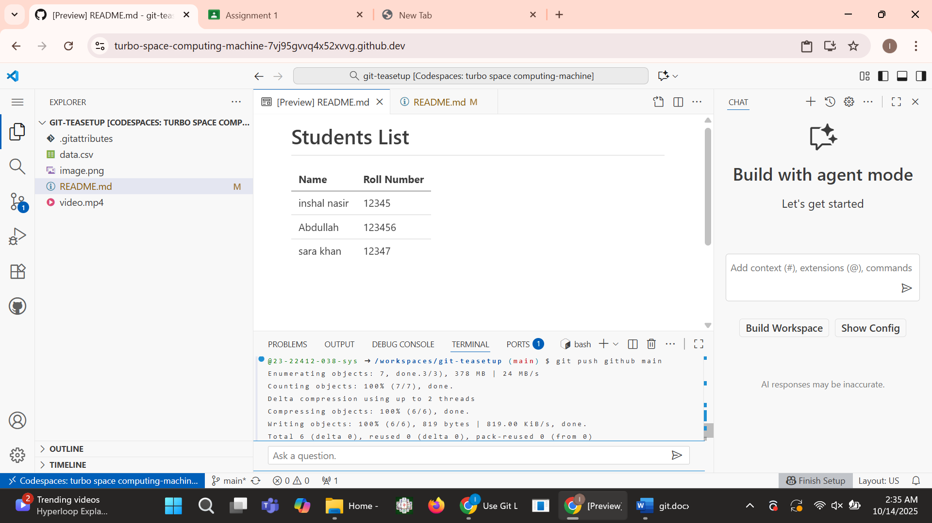
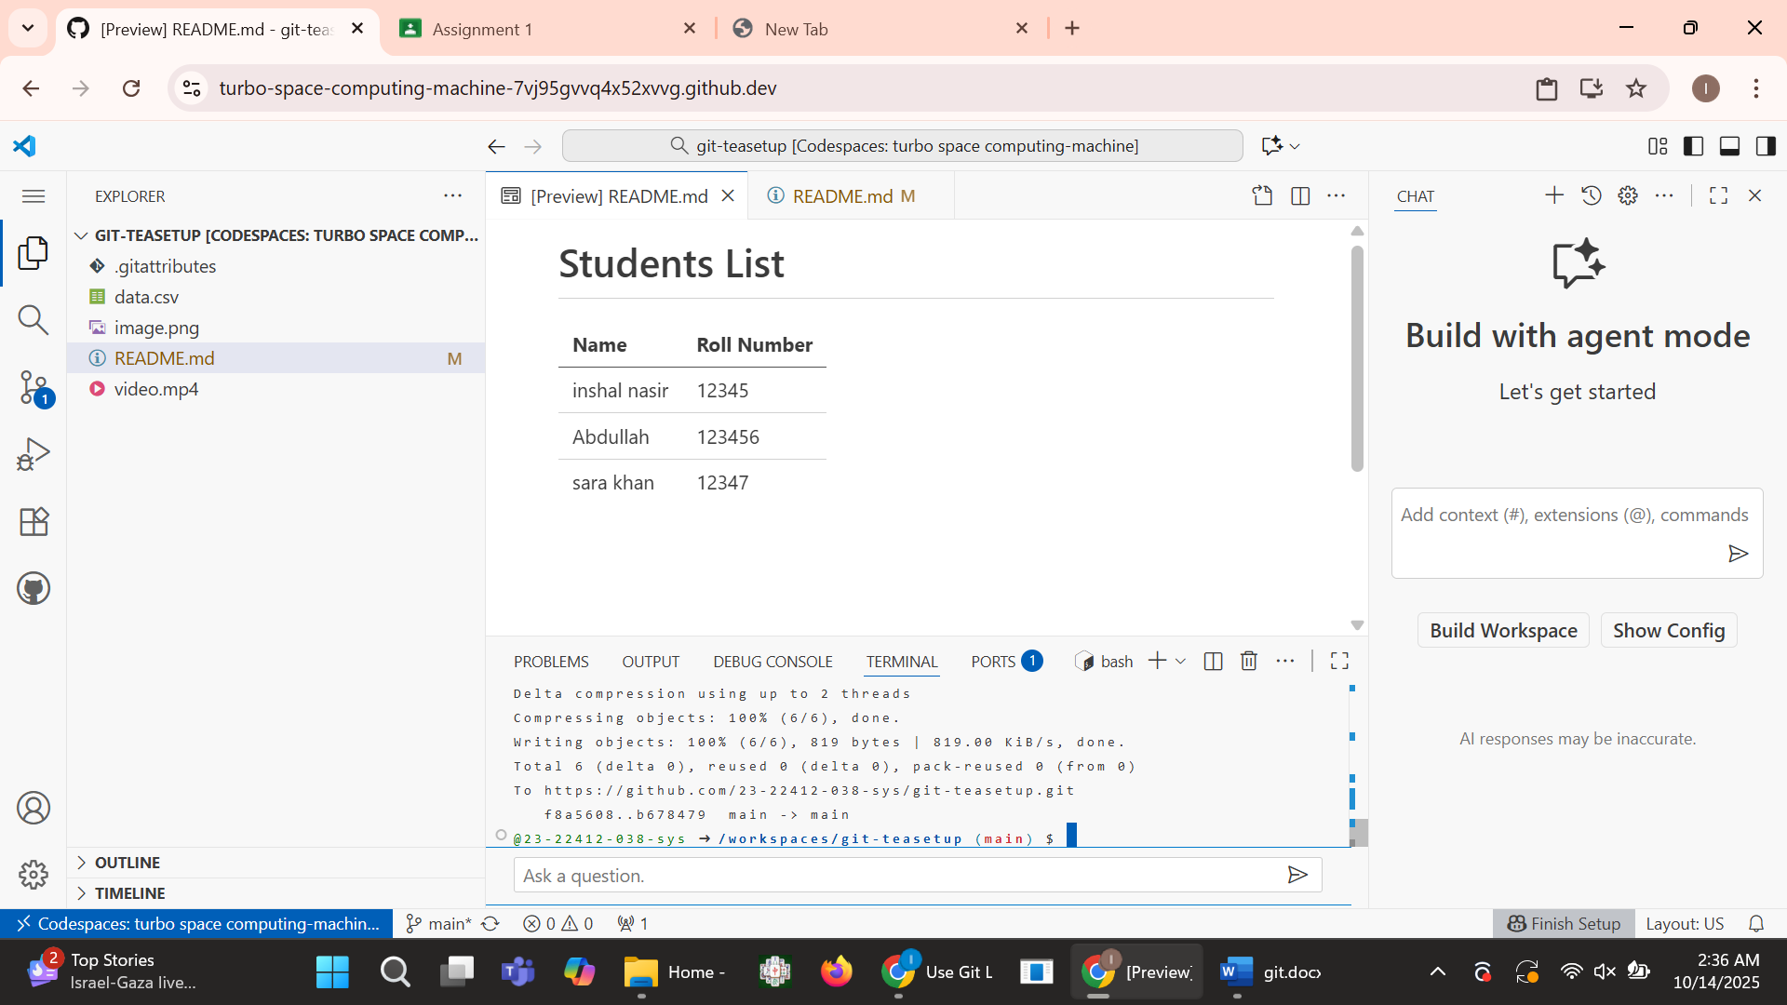
- Storing large files
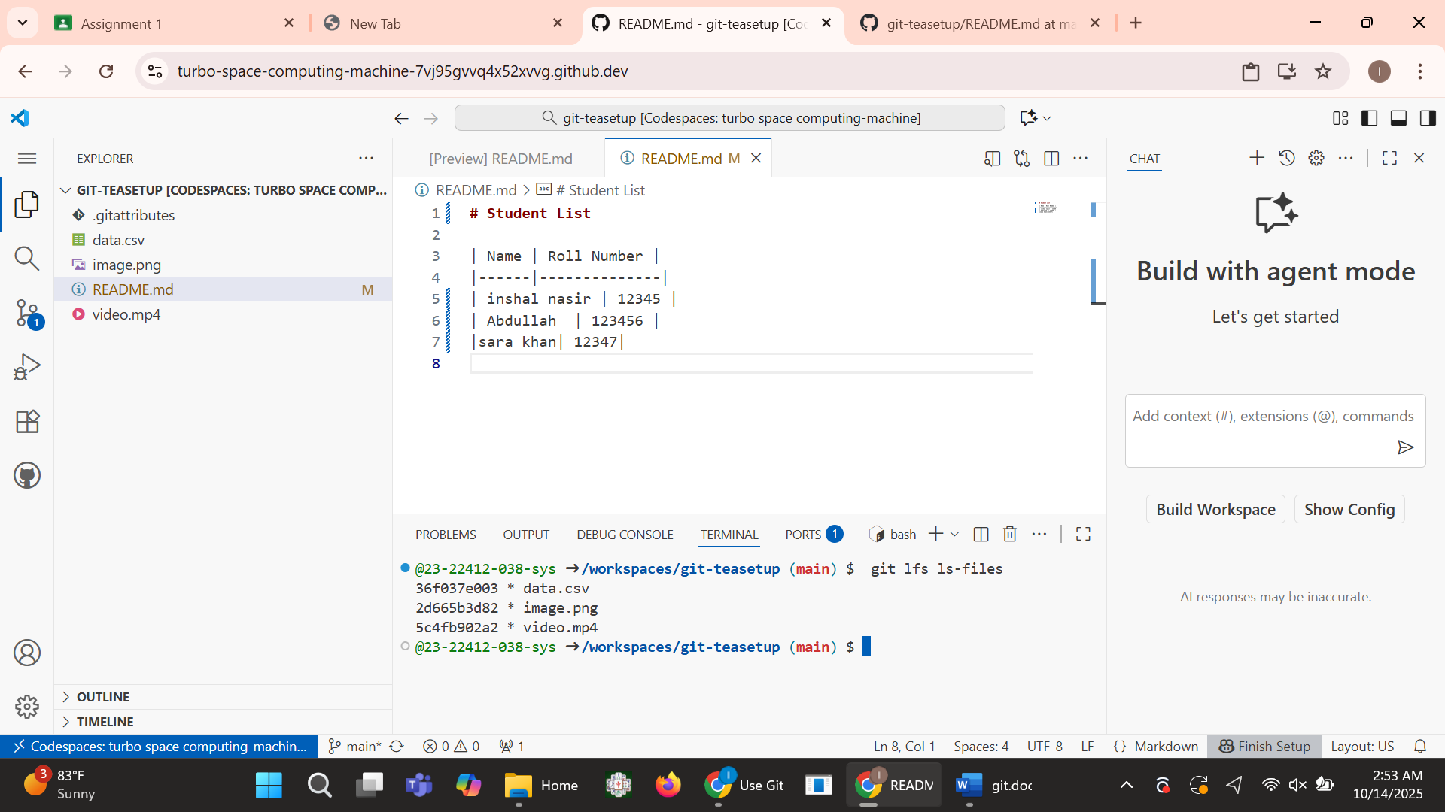
Task 4: Create a Portfolio/CV with GitHub Page:
- Created files in new resp 23-22412-038-sys.github.io
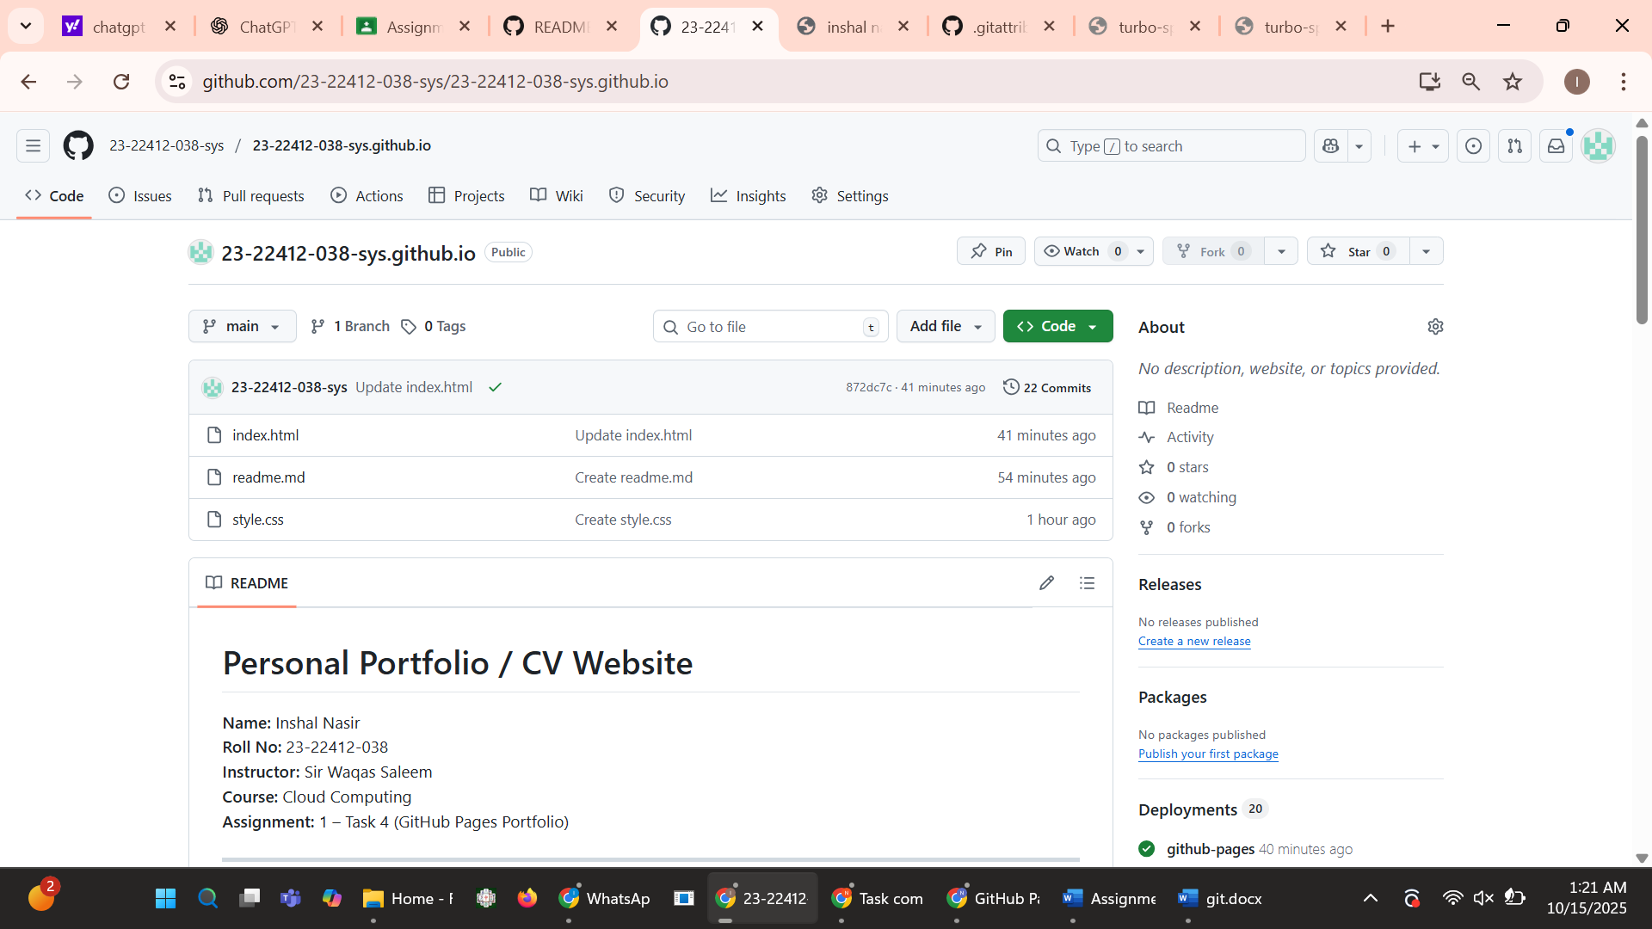
- Readme.md file show portfolio
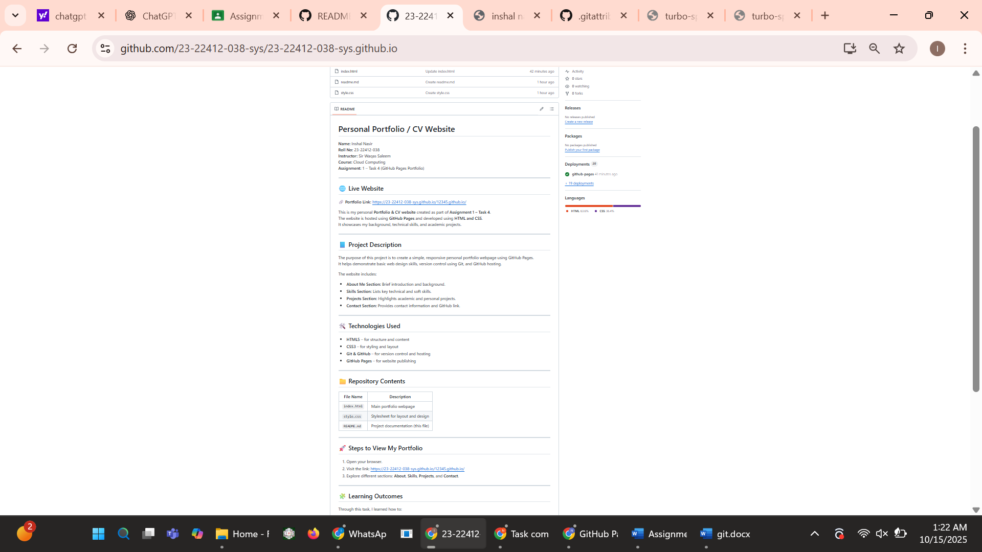
- By clicking on link this site will appear:
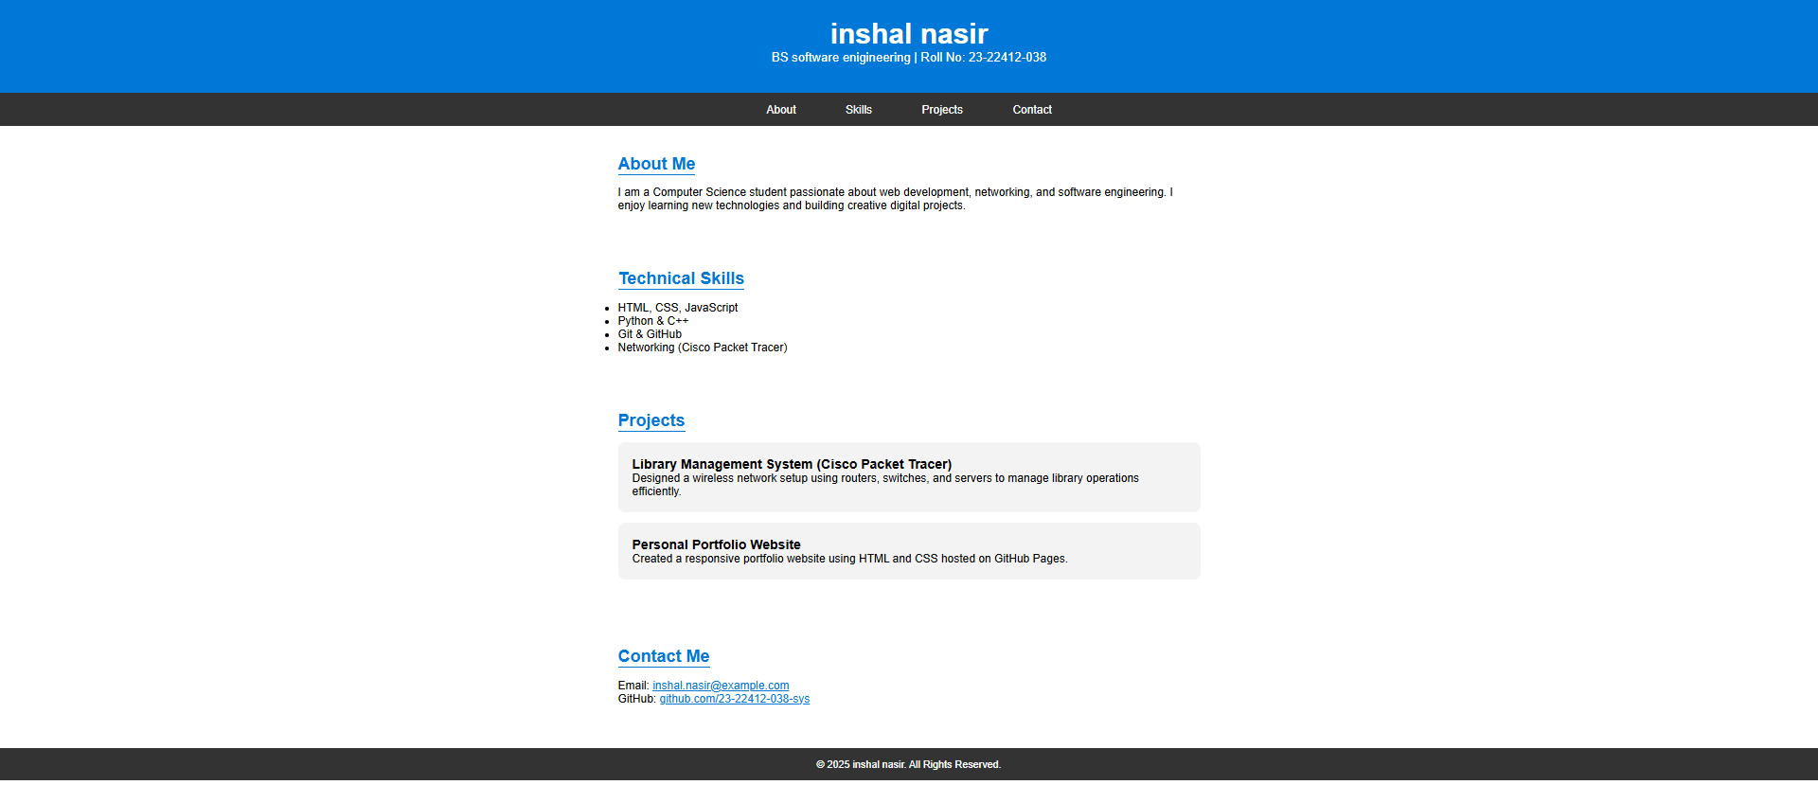
- Portfolio Link: https://23-22412-038-sys.github.io/
______________________________________________

